CIS 221 Module 2 Practice Questions and Problems

1. Write a statement that uses a function to calculate 5 to the 3rd power

5 ** 3

1. Write a statement that calculates 5 to the 3rd power using an operator

Pow(5,3)

1. Write the Python code that would allow you to use the pow() function (from the math module) in your program without actually loading all of the math functions into your program.

Math.pow(5,3)

1. Write the Python code that would allow you to draw a circle without giving your program access to any of the other turtle functions.

Python.circle(45)

1. How is the Unicode character set different from the ASCII character set?

An example of Unicode is \uB4oT, while ASCII uses 1 and 0

1. What will the following code display?



I’m Bond, James Bond

1. What will the following code display?

In this example, what is the purpose of str(lastn) and why is str necessary?

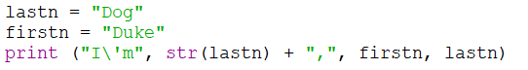

Str(lastn) concatenates the phrase “Dog” to the variable lastn. Without using the str, “Dog” would have no variable assigned to and would simply be words on the screen

1. What will the following code display?

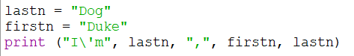

I’m Dog, Duke Dog

1. Open the file ColorShapes.py that you downloaded from Canvas Module 2.

Note the use of begin_fill and end_fill to color in the shape.

Note the use of 2 arguments (before we only used 1) on the .circle function. The second argument indicates how many sides the “circle” will have – 5 sides will actually draw a pentagon.

In the turtle.write function, we can change the font, as well as font size and boldness.

Change some of the arguments to see the effect on the resulting drawing – don’t worry about changing it or messing it up – you can always download the original again from Canvas if you want to.